**Purpose**

**A repository of things Indian in the Caribbean**

"Girmitiyas” (derived from the Bhojpuri word "girmit" for “agreement”) refers to the generations of Indians who were taken from India by the Europeans to work as indentured laborers in the sugar plantations around the world during the middle and late 19th century. These areas include Mauritius, Seychelles, Fiji, South Africa, East Africa, Malay Peninsula, Suriname, Guyana, Trinidad, Suriname, Danish West Indies, St Croix, and other Caribbean islands. The girmitiyas signed a contract that guaranteed bounded labor for five years (with option to renew for another 5 years), after which they could return to India. If they renewed their contract after 5 years, they could return to India at the expense of the British Colonial government. Many girmitiyas chose to remain in the diasporic colonies and chose to settle in exchange for return passages and a some received small plots of land.

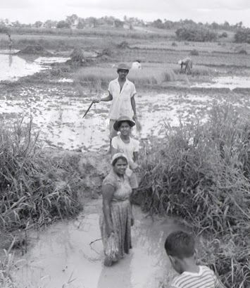Approximately 1.2 million girmitiyas were transported from India in a span of over eighty years, with more than half of them taken to the Caribbean. Descendants of the original girmitiyas can be found in large communities in Guyana, Trinidad and Suriname, and in other island nations in the Caribbean. The girmitiyas, as well as their descendants, have made progress in various areas, while overcoming difficult challenges. Some of those challenges, and new ones, continue to plague the children of the original girmitiyas today.

In many ways, the history of the girmitiyas who crossed the *kala pani* (“black water”) remains silent, or was silenced by colonial hegemony. This site is an attempt to give recognition to the presence of girmitiyas in the Caribbean. While our focus is primarily on Indians in the Caribbean, we will strive to encourage communication, cooperation and interaction with girmitiyas outside the region. We recognize that many scholars are engaged in researching, documenting and archiving our history so that we can have a common narrative. It is important that this narrative gets filtered down to members of our community so that they can connect with the past and define our proper role in our respective Caribbean societies.